LAB EXPERIMENTS

NAME: V. PRIYADHARSHINI
REG NO: 192511372
SLOT: D
COURSE CODE: ECA1415
COURSE: EMBEDDED SYSTEM

EXPERIMENT:11
STUDY OF GPIO &AMP; BIT ADDRESSING IN AT89C51
PROGRAM:
#include <reg51.h>
sbit LED1 = P1^0;
sbit LED2 = P1^1;
void delay ()
{
unsigned int i, j;
for (i = 0; i < 200; i++)
{
for (j = 0; j < 1000; j++);
}
}
void main ()
{
while (1)
{
LED1 = 1;
LED2 = 0;
delay ();
LED1 = 0;
LED2 = 1;
delay ();
}
}
OUTPUT:

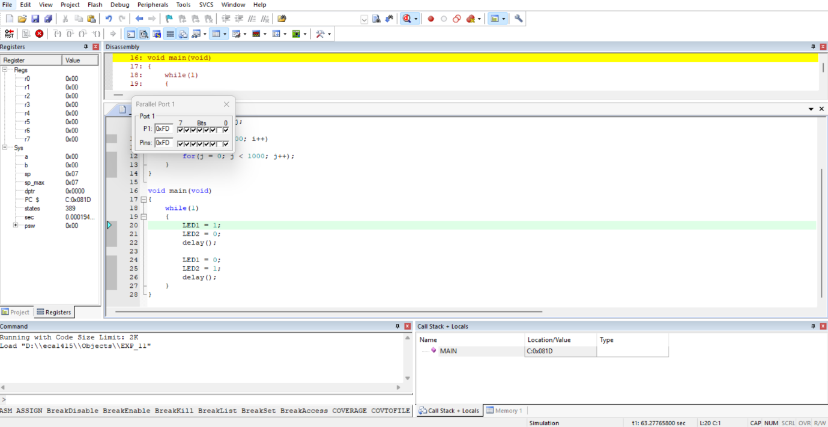

EXPERIMENT: 12
EMBEDDED C PROGRAM TO MULTIPLY TWO 16-BIT BINARY
NUMBERS
PROGRAM:
#include <reg51.h>
void main ()
{
unsigned int num1, num2;
unsigned long int product;
while (1)
{
num1 = 0x2222;
num2 = 0xBBBB;
product = (unsigned long int) num1 * num2;
P0 = product & 0xFF;
P1 = (product & 0xFF00) >> 8;
P2 = (product & 0xFF0000) >> 16;
P3 = (product & 0xFF000000) >> 24;
}
}

OUTPUT:

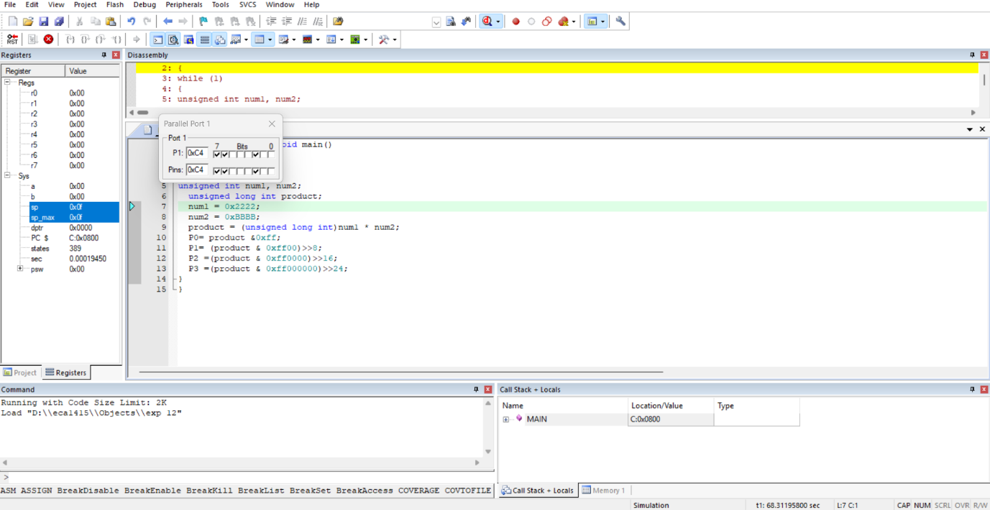

EXPERIMENT: 13
EMBEDDED C PROGRAM TO ADD AN ARRAY OF 16-BIT NUMBERS
AND STORE THE 32-BIT RESULT IN INTERNAL RAM
PROGRAM:
#include <reg51.h>
void main(void)
{
unsigned int i;
unsigned int array [5] = {0x1111, 0x2222, 0x8888, 0x4444, 0xABCD};
unsigned long int sum = 0;
for (i = 0; i < 5; i++)
{
sum = sum + array[i];
}
P0 = (unsigned char) (sum & 0xFF); // Lower 8 bits
P1 = (unsigned char) ((sum >> 8) & 0xFF); // Next 8 bits
P2 = (unsigned char) ((sum >> 16) & 0xFF); // Upper 8 bits

While (1);
}

OUTPUT:
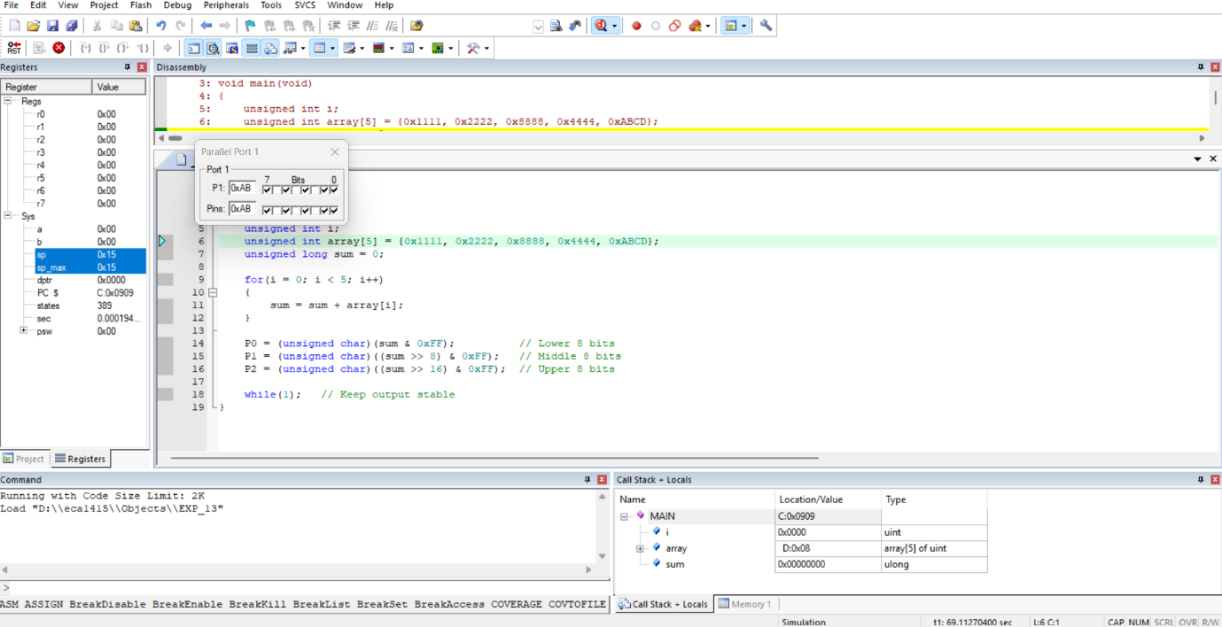

EXPERIMENT: 14
EMBEDDED C PROGRAM TO DISPLAY “HELLO WORLD”
MESSAGE
PROGRAM:
#include <reg51.h>
#include <stdio.h>
void main(void)
{
SCON = 0x50; // UART mode 1, 8-bit data, enable receiver
TMOD = 0x20; // Timer 1, Mode 2 (8-bit auto reload)
TH1 = 0xFD; // Reload value for 9600 baud rate
TR1 = 1; // Start Timer 1
TI = 1; // Set TI to send the first character
while (1)
{
printf ("Hello World!\n");
}
}

OUTPUT:
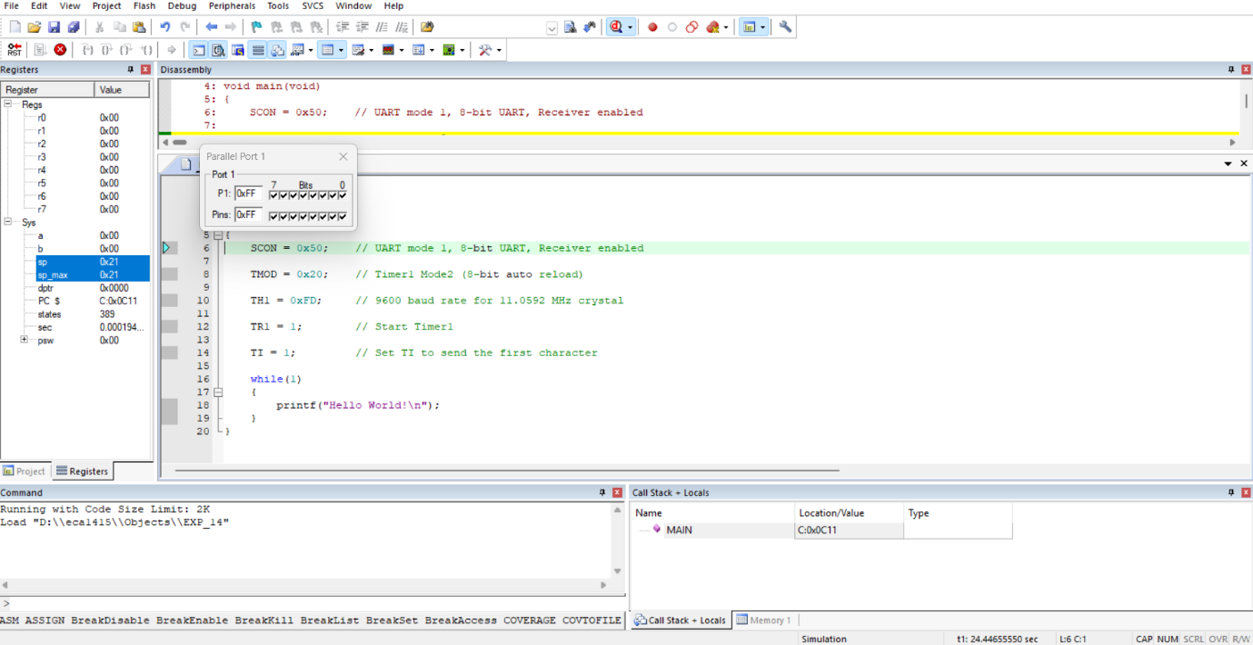

EXPERIMENT: 15
EMBEDDED C PROGRAM TO CONVERT THE HEXADECIMAL DATA 0XCFH TO DECIMAL AND DISPLAY THE DIGITS ON PORTS P0, P1 AND P2
PROGRAM:
#include <reg51.h>
void main(void)
{
unsigned char hexa = 0x08;
unsigned char hundreds, tens, units;
ACC = hexa;
B = 10;
ACC = ACC / B;
units = B;
B = 10;
ACC = ACC / B;
tens = B;
hundreds = ACC;
P0 = units;
P1 = tens;
P2 = hundreds;
while (1);
}
OUTPUT:
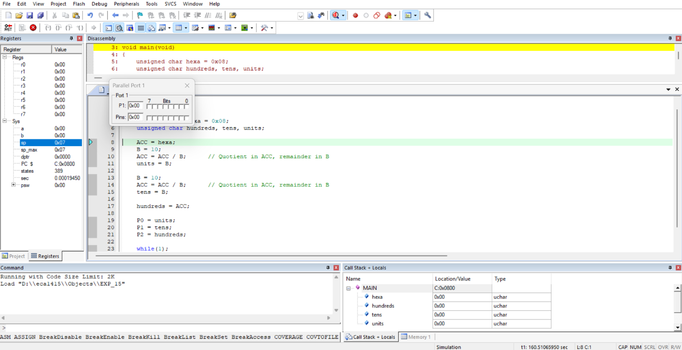

EXPERIMENT: 16
SERIAL INTERRUPT USING UART (KEYBOARD INPUT) IN
KEIL
PROGRAM:
#include <reg51.h>
#include <stdio.h>
void serial_ISR(void) interrupt 4
{
char ch;
if(RI)
{
RI = 0; // Clear receive interrupt flag
ch = SBUF; // Read received character
printf("\n>>> INTERRUPT RECEIVED: ");
printf("%c\n", ch);
}
}
void delay(void)
{
unsigned int i;
for (i = 0; i < 50000; i++); // Delay for visibility
}
void main(void)
{
SCON = 0x50; // UART mode 1, 8-bit, REN enabled
TMOD = 0x20; // Timer1 Mode 2 (Auto Reload)
TH1 = 0xFD; // Baud rate 9600
TR1 = 1; // Start Timer1
IE = 0x90; // EA = 1, ES = 1 (Enable Serial Interrupt)
TI = 1; // Enable printf
while (1)
{
printf ("Hello World\n");
delay ();
}
}
OUTPUT:
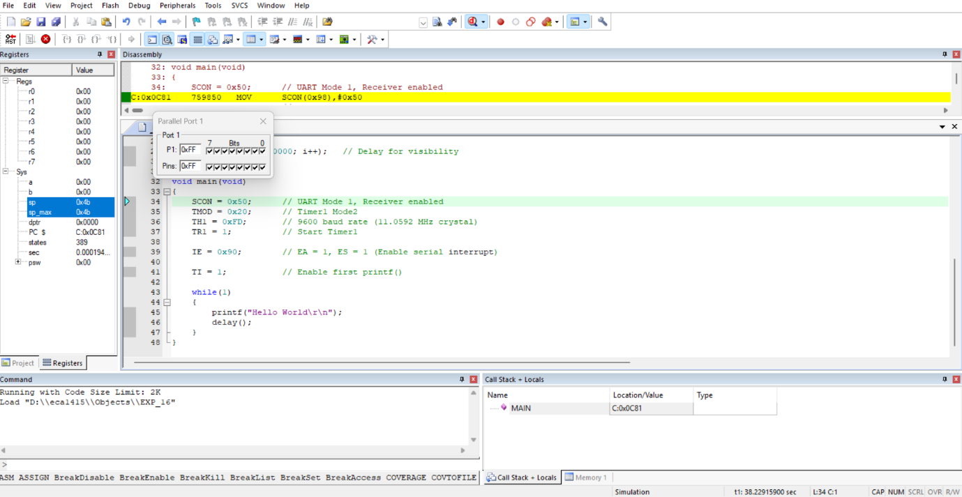

EXPERIMENT: 17
UART INTERFACING USING INTERRUPT IN
KEIL
PROGRAM:
#include <reg51.h>
void serial_ISR(void) interrupt 4
{
if(RI)
{
P1 = SBUF; // Display received data on Port 1
RI = 0; // Clear receive interrupt flag
}
}
void main(void)
{
TMOD = 0x20; // Timer1 Mode 2 (8-bit auto reload)
TH1 = 0xFD; // 9600 baud rate
SCON = 0x50; // UART Mode 1, 8-bit, enable receiver
TR1 = 1; // Start Timer1
ES = 1; // Enable Serial Interrupt
EA = 1; // Enable Global Interrupt

while(1);
}

OUTPUT:
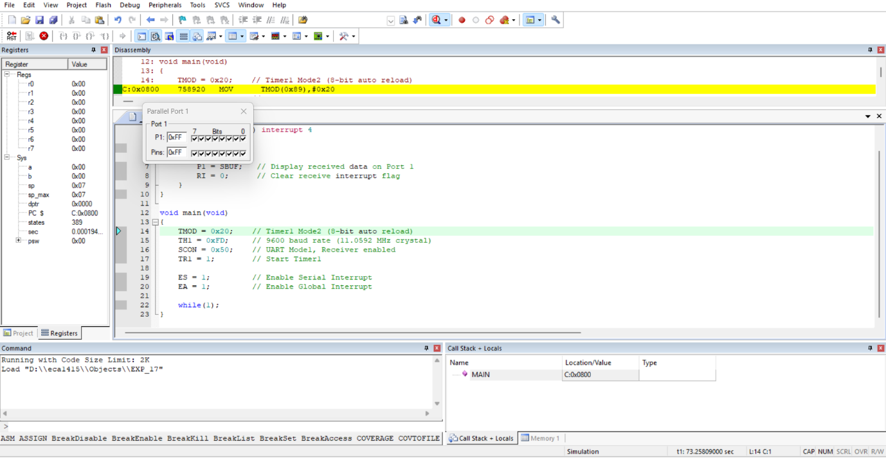

EXPERIMENT: 18
GENERATION OF PWM USING TIMER
INTERRUPT
PROGRAM:
#include <reg51.h>
sbit PWM = P1^0;
unsigned char count = 0;
unsigned char duty = 100; // Change this value (0–200)

void timer0_ISR(void) interrupt 1
{
TH0 = 0xFC; // Reload for 1 ms delay
TL0 = 0x66;
count++;
if(count < duty)
PWM = 1; // ON time
else
PWM = 0; // OFF time
if(count >= 200) // Total period = 200 ms
count = 0;
}
void main(void)
{
TMOD = 0x01; // Timer0 Mode 1 (16-bit)
TH0 = 0xFC; // 1 ms preload
TL0 = 0x66;
IE = 0x82; // EA = 1, ET0 = 1
TR0 = 1; // Start Timer0
while(1);
}
OUTPUT:
